Part1: summery of the experimental results

Compared CAD flow and Denotations:
The results of the following five flows are reported and compared.
- baseline algorithm: place-route (non-retimed)
- placement -> deterministic retiming -> routing (post-place-determ-retimed)
- placement -> ssta retiming -> routing (post-place-ssta-retimed)
- placement -> routing -> deterministic retiming (post- route -determ-retimed)
- placement -> routing -> ssta retiming (post-route-ssta-retimed)

Summarized results:
(Since the improvement of retiming results is correlated to the circuit design, I intend to show the results from MCNC and QUIP benchmarks separately. All entries show the average improvement to the baseline algorithm (non-retimed case))

MCNC:
 | post-place-determ-retimed | post-place-ssta-retimed | post- route -determ-retimed | post-route-ssta-retimed
Nominal | 6.54% | 3.80% | 6.86% | 5.63%
Mean | 3.43% | 3.77% | 3.35% | 3.80%
Var | 3.25% | 3.70% | 3.26% | 5.13%
Yield | 8.40% | 9.68% | 8.42% | 9.89%

QUIQ:
 | post-place-determ-retimed | post-place-ssta-retimed | post- route -determ-retimed | post-route-ssta-retimed
Nominal | 8.73% | 4.54% | 4.85% | 2.95%
Mean | 2.96% | 4.78% | 2.63% | 4.76%
Var | 3.08% | 6.74% | 3.33% | 6.78%
Yield | 16.20% | 24.03% | 17.61% | 24.28%

The detailed data are shown at the end of this report.
Part2: Analysis the indicator of the gain from statistical retiming

Motivation:
To justify the runtime overhead of the statistical retiming, it’s necessary to study on the indicator of the gain that can be obtained from statistical retiming comparing to the deterministic algorithm, so that we can propose a runtime efficient CAD flow.

Main conclusions:
The topology of the critical path decides how much gain can be obtained by the statistical retiming compared to the deterministic retiming. More specifically, for all statistical critical paths in a circuit, the longer is the length of the overlapped part, the less gain we can get from statistical retiming.

Rationality:
When two critical paths share a long common part, the sensitivity to variation of these two paths is similar. Therefore, as long as one of each is optimized by the deterministic retiming, the other one is also optimized, which make there is no much difference between deterministic retiming and statistical retiming.
On the other hand, if two critical paths have zero-overlap, the deterministic won’t distinguish their sensitivity to the process variation, and optimize them separately. But the statistical retiming gets a chance to choose the more sensitive path to optimize, which more likely produces larger gain.

Detailed analysis of the indicator:

- Mean improvement and yield improvement are highly correlated as shown in the below figure. Therefore, we can draw the similar conclusions based on either “mean” or “yield rate” if we only interested in the trend of the improvement.
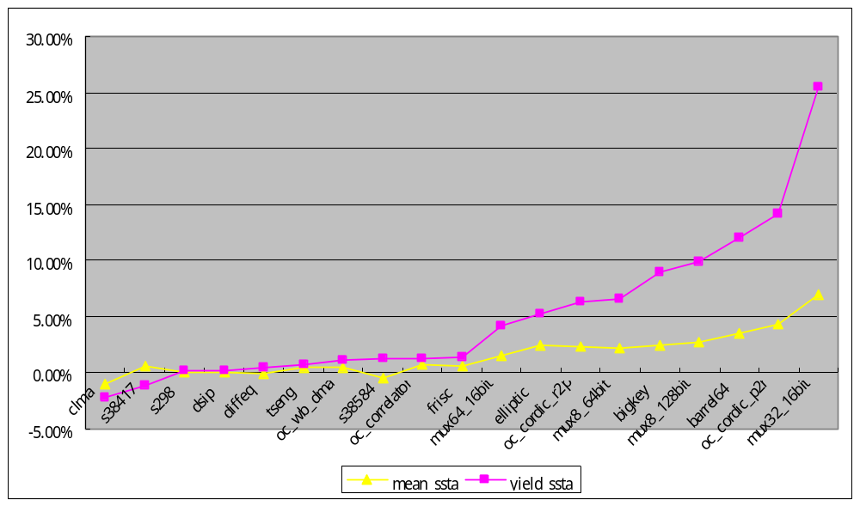

Continue in the next page.

- I traced into the topologies of top-10 critical path and obtained the overlap part of each pair. The following two matrices (path sharing matrix) show the length of the sharing part between each of two top-10 critical paths. In the path sharing matrix, entry (i,j) is the number of timing nodes shared by both path i and path j. The less of the non-diagonal values, the less of critical path overlap. It’s clearly to see that the path sharing matrix of bigkey is much sparser than that of s38417, which indicates that statistical retiming obtains more gain on bigkey compared to s38417.

Bigkey | S38417
21 9 5 5 5 0 2 0 2 0  9 21 5 5 5 2 0 2 0 0  5 5 23 9 9 0 0 0 0 6  5 5 9 23 9 0 0 0 0 2  5 5 9 9 23 0 0 0 0 2  0 2 0 0 0 23 0 2 9 0  2 0 0 0 0 0 23 9 2 0  0 2 0 0 0 2 9 23 0 0  2 0 0 0 0 9 2 0 23 0  0 0 6 2 2 0 0 0 0 25 | 58 26 34 31 26 31 22 30 18 18  26 58 31 34 32 27 19 18 30 23  34 31 58 26 31 26 18 26 22 22  31 34 26 58 27 32 23 22 26 19  26 32 31 27 58 34 26 18 23 30  31 27 26 32 34 58 30 22 19 26  22 19 18 23 26 30 57 31 27 34  30 18 26 22 18 22 31 57 26 26  18 30 22 26 23 19 27 26 57 32  18 23 22 19 30 26 34 26 32 57

Continue in the next page.

The following figure shows the statistics of the overlap length (bars) of each circuit and the gain (mean value improvement, blue line) obtained from statistical retiming compared to deterministic retiming. To see the indicator clearly, I separate the whole benchmark set into two parts, one (the red area) includes those circuits whose gain is larger than 1%, the other part (the yellow area)includes others. It’s clear to see that there are 66% (6 out of 9) circuits in red area sharing less than 0.02 unit critical paths, while there are 90% (9 out of 10) circuits in the yellow area sharing more than 0.03 unit critical path. This observation justifies our conclusions.
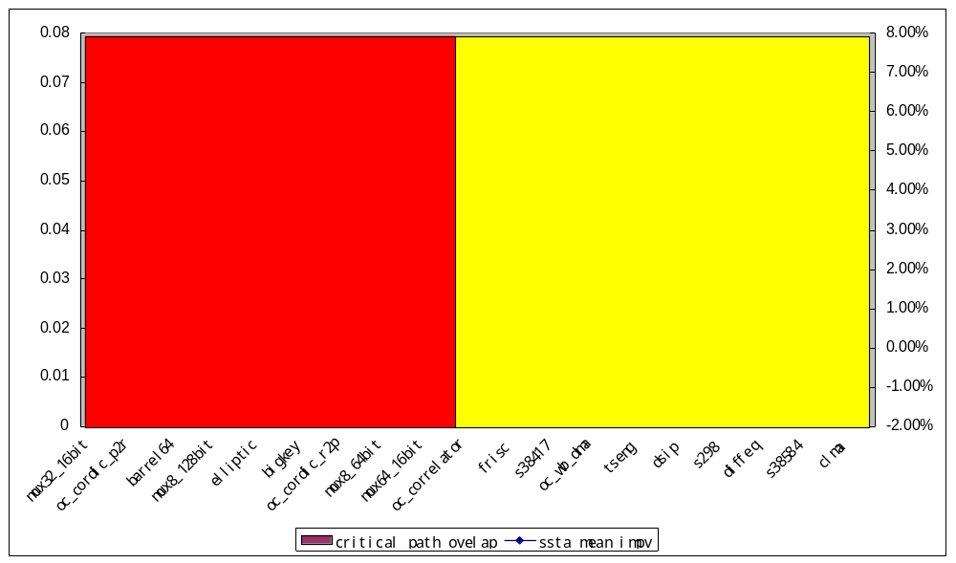

Continue in the next page.

The following figure shows the number of the free critical paths (bars) of each circuit and the gain (mean value improvement, blue line) obtained from statistical retiming compared to deterministic retiming. Here, the free critical path means the critical path who has less than 10% overlap with any of the other critical paths. The rough trend obtained from this figure is that the more free critical paths, the more gain can be obtained from statistical retiming.
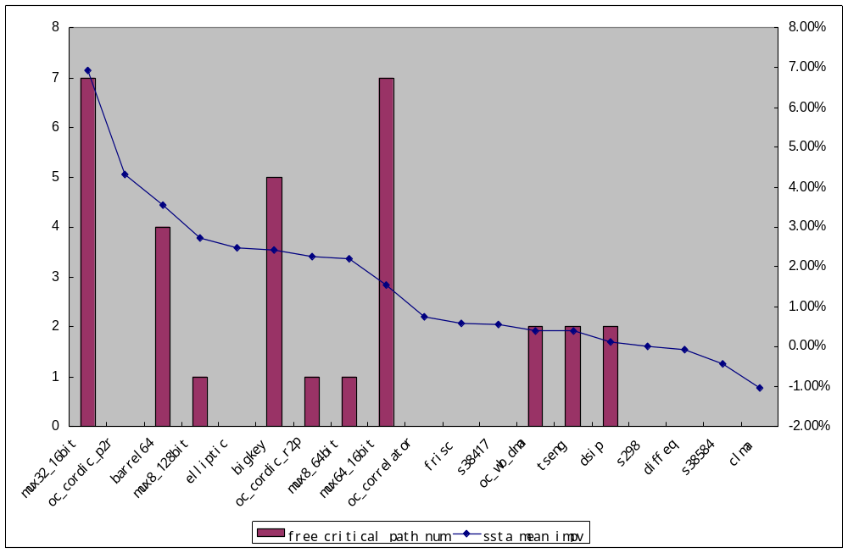

Continue in the next page.

- It's hard to get an indicator purely based on the results obtained from the previous CAD stages. In other words, after we perform the deterministic retiming, we cannot say much about how much gain we can get from statistical retiming. The following figure shows the statistics for all tested circuit. Line “yield_impv_ssta” (yellow) shows the yield rate improvement by comparing post-place-ssta-retimed to post-place-determ-retimed. All benchmarks are sorted by “yield_impv_determ”, which is yield rate improvement by comparing post-place-determ-retimed to non-retimed.
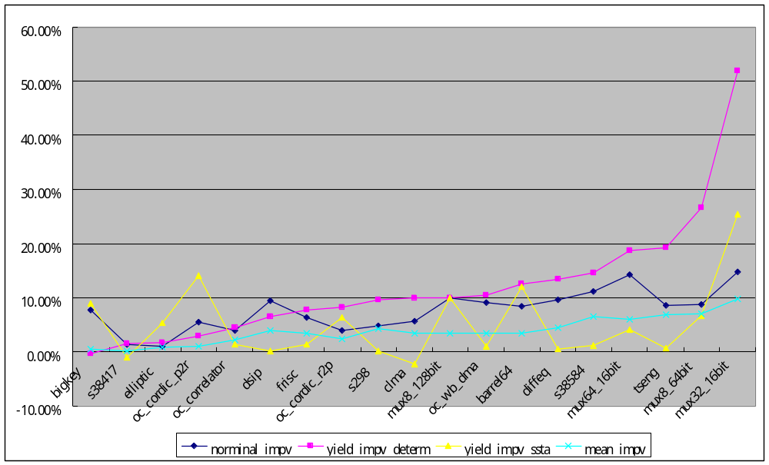

Continue in the next page.

Atppendix:

Detailed results for Post-placement retiming

 |  | nonretimed |  |  |  |  |  | determ |  |  |  |  |  |  |  | ssta
 | norminal | mean | var |  | norminal | (impv) | mean | (impv) | var | (impv) |  | norminal | (impv1) | (impv2) | mean | (impv1) | (impv2) | var | (impv1) | (impv2)
bigkey | 1.01E-08 | 1.13E-08 | 1.33E-09 |  | 9.37E-09 | 7.69% | 1.13E-08 | -0.57% | 1.43E-09 | 7.57% |  | 9.41E-09 | -7.21E-02 | 0.52% | 1.10E-08 | -2.99% | -2.43% | 1.34E-09 | 1.03% | -6.08%
dsip | 8.91E-09 | 1.00E-08 | 1.98E-09 |  | 8.08E-09 | 9.37% | 9.63E-09 | -3.98% | 2.00E-09 | 0.84% |  | 8.67E-09 | -2.66E-02 | 6.89% | 9.62E-09 | -4.10% | -0.12% | 2.00E-09 | 0.84% | 0.00%
s298 | 4.03E-08 | 4.27E-08 | 6.41E-09 |  | 3.84E-08 | 4.87% | 4.09E-08 | -4.32% | 6.54E-09 | 1.92% |  | 3.84E-08 | -4.87E-02 | 0.00% | 4.09E-08 | -4.33% | -0.01% | 6.51E-09 | 1.43% | -0.49%
s38584 | 1.81E-08 | 1.96E-08 | 3.69E-09 |  | 1.61E-08 | 11.16% | 1.83E-08 | -6.50% | 3.64E-09 | -1.57% |  | 1.65E-08 | -8.72E-02 | 2.67% | 1.84E-08 | -6.08% | 0.44% | 3.40E-09 | -7.91% | -6.45%
s38417 | 2.44E-08 | 2.94E-08 | 4.10E-09 |  | 2.41E-08 | 1.35% | 2.93E-08 | -0.16% | 3.94E-09 | -3.87% |  | 2.48E-08 | 1.42E-02 | 2.73% | 2.92E-08 | -0.71% | -0.55% | 4.26E-09 | 3.96% | 8.14%
clma | 4.18E-08 | 4.49E-08 | 6.04E-09 |  | 3.95E-08 | 5.57% | 4.34E-08 | -3.43% | 5.78E-09 | -4.32% |  | 4.07E-08 | -2.82E-02 | 2.83% | 4.38E-08 | -2.42% | 1.05% | 5.80E-09 | -3.89% | 0.46%
tseng | 2.28E-08 | 2.41E-08 | 4.31E-09 |  | 2.09E-08 | 8.58% | 2.24E-08 | -6.88% | 4.03E-09 | -6.69% |  | 2.09E-08 | -8.47E-02 | 0.11% | 2.23E-08 | -7.25% | -0.39% | 4.01E-09 | -7.02% | -0.35%
elliptic | 2.81E-08 | 3.10E-08 | 4.89E-09 |  | 2.78E-08 | 1.05% | 3.08E-08 | -0.78% | 4.89E-09 | 0.11% |  | 2.87E-08 | 2.28E-02 | 3.26% | 3.00E-08 | -3.24% | -2.49% | 4.87E-09 | -0.27% | -0.38%
frisc | 2.81E-08 | 3.10E-08 | 4.89E-09 |  | 2.63E-08 | 6.26% | 3.00E-08 | -3.37% | 4.90E-09 | 0.20% |  | 2.74E-08 | -2.15E-02 | 4.19% | 2.98E-08 | -3.92% | -0.57% | 4.84E-09 | -1.03% | -1.23%
diffeq | 2.25E-08 | 2.57E-08 | 5.86E-09 |  | 2.04E-08 | 9.54% | 2.45E-08 | -4.43% | 4.96E-09 | -15.44% |  | 2.05E-08 | -9.21E-02 | 0.36% | 2.46E-08 | -4.35% | 0.09% | 4.86E-09 | -17.05% | -1.91%
(ave) | 2.45E-08 | 2.70E-08 | 4.35E-09 |  | 2.31E-08 | 6.54% | 2.61E-08 | -3.43% | 4.21E-09 | -3.25% |  | 2.36E-08 | -3.80E-02 | 2.16% | 2.60E-08 | -3.77% | -0.35% | 4.19E-09 | -3.70% | -0.46%
barrel64 | 1.50E-08 | 1.70E-08 | 2.84E-09 |  | 1.38E-08 | 8.39% | 1.64E-08 | -3.43% | 2.68E-09 | -5.75% |  | 1.38E-08 | -8.10E-02 | 0.31% | 1.58E-08 | -6.86% | -3.55% | 2.40E-09 | -15.57% | -10.42%
mux64_16bit | 9.74E-09 | 1.10E-08 | 1.70E-09 |  | 8.34E-09 | 14.32% | 1.04E-08 | -5.94% | 1.67E-09 | -1.78% |  | 8.35E-09 | -1.43E-01 | 0.05% | 1.02E-08 | -7.40% | -1.55% | 1.61E-09 | -5.10% | -3.39%
mux8_128bit | 6.40E-09 | 8.46E-09 | 1.41E-09 |  | 5.76E-09 | 9.92% | 8.17E-09 | -3.44% | 1.40E-09 | -0.61% |  | 6.00E-09 | -6.27E-02 | 3.89% | 7.95E-09 | -6.06% | -2.72% | 1.24E-09 | -12.27% | -11.73%
mux32_16bit | 7.77E-09 | 9.89E-09 | 1.79E-09 |  | 6.62E-09 | 14.84% | 8.92E-09 | -9.85% | 1.61E-09 | -10.12% |  | 6.75E-09 | -1.32E-01 | 1.94% | 8.30E-09 | -16.10% | -6.93% | 1.33E-09 | -25.76% | -17.40%
mux8_64bit | 6.18E-09 | 8.16E-09 | 1.45E-09 |  | 5.64E-09 | 8.73% | 7.58E-09 | -7.10% | 1.29E-09 | -11.39% |  | 5.73E-09 | -7.20E-02 | 1.65% | 7.42E-09 | -9.14% | -2.20% | 1.20E-09 | -17.30% | -6.67%
oc_cordic_r2p | 2.60E-08 | 3.61E-08 | 5.71E-09 |  | 2.50E-08 | 3.94% | 3.52E-08 | -2.39% | 5.41E-09 | -5.33% |  | 2.55E-08 | -2.12E-02 | 1.86% | 3.44E-08 | -4.61% | -2.27% | 5.19E-09 | -9.20% | -4.08%
oc_wb_dma | 2.06E-08 | 2.15E-08 | 3.32E-09 |  | 1.88E-08 | 9.09% | 2.07E-08 | -3.46% | 3.13E-09 | -5.62% |  | 1.89E-08 | -8.61E-02 | 0.52% | 2.07E-08 | -3.84% | -0.40% | 3.10E-09 | -6.61% | -1.05%
oc_cordic_p2r | 2.22E-08 | 2.93E-08 | 4.62E-09 |  | 2.10E-08 | 5.48% | 2.90E-08 | -1.04% | 4.64E-09 | 0.33% |  | 2.19E-08 | -1.32E-02 | 4.22% | 2.77E-08 | -5.31% | -4.31% | 4.20E-09 | -9.22% | -9.52%
oc_correlator | 1.15E-07 | 1.19E-07 | 2.36E-08 |  | 1.10E-07 | 3.89% | 1.17E-07 | -2.28% | 2.32E-08 | -1.73% |  | 1.11E-07 | -2.87E-02 | 1.06% | 1.16E-07 | -3.00% | -0.74% | 2.31E-08 | -2.33% | -0.61%
(ave) | 2.54E-08 | 2.90E-08 | 5.17E-09 |  | 2.39E-08 | 8.73% | 2.81E-08 | -2.96% | 5.01E-09 | -3.08% |  | 2.42E-08 | -4.54E-02 | 1.46% | 2.76E-08 | -4.78% | -1.88% | 4.82E-09 | -6.74% | -3.78%

 | nonretimed |  | determ |  |  |  | ssta
 | yield |  | yield | (impv) |  | yield | (impv) | (impv2)
bigkey | 0.774902 |  | 0.772499 | -0.31% |  | 0.841345 | 8.91% | 8.57%
dsip | 0.788509 |  | 0.839918 | 6.52% |  | 0.841345 | 0.17% | 6.70%
s298 | 0.765986 |  | 0.840009 | 9.66% |  | 0.841345 | 0.16% | 9.84%
s38584 | 0.725012 |  | 0.830955 | 14.61% |  | 0.841345 | 1.25% | 16.05%
s38417 | 0.838635 |  | 0.850908 | 1.46% |  | 0.841345 | -1.12% | 0.32%
clma | 0.782705 |  | 0.860642 | 9.96% |  | 0.841345 | -2.24% | 7.49%
tseng | 0.700485 |  | 0.835192 | 19.23% |  | 0.841345 | 0.74% | 20.11%
elliptic | 0.785645 |  | 0.799469 | 1.76% |  | 0.841345 | 5.24% | 7.09%
frisc | 0.770629 |  | 0.82966 | 7.66% |  | 0.841345 | 1.41% | 9.18%
diffeq | 0.73867 |  | 0.837747 | 13.41% |  | 0.841345 | 0.43% | 13.90%
(ave) | 0.767118 |  | 8.30E-01 | 8.40% |  | 8.41E-01 | 1.49% | 9.68%
barrel64 | 0.667816 |  | 0.751235 | 12.49% |  | 0.841345 | 11.99% | 25.98%
mux64_16bit | 0.680168 |  | 0.807751 | 18.76% |  | 0.841345 | 4.16% | 23.70%
mux8_128bit | 0.69606 |  | 0.765475 | 9.97% |  | 0.841345 | 9.91% | 20.87%
mux32_16bit | 0.44167 |  | 0.670719 | 51.86% |  | 0.841345 | 25.44% | 90.49%
mux8_64bit | 0.623111 |  | 0.789265 | 26.67% |  | 0.841345 | 6.60% | 35.02%
oc_cordic_r2p | 0.731492 |  | 0.791371 | 8.19% |  | 0.841345 | 6.31% | 15.02%
oc_wb_dma | 0.753274 |  | 0.832279 | 10.49% |  | 0.841345 | 1.09% | 11.69%
oc_cordic_p2r | 0.716118 |  | 0.73739 | 2.97% |  | 0.841345 | 14.10% | 17.49%
oc_correlator | 0.795382 |  | 0.830673 | 4.44% |  | 0.841345 | 1.28% | 5.78%
(ave) | 6.78E-01 |  | 7.75E-01 | 16.20% |  | 8.41E-01 | 8.99% | 24.03%

Detailed results for Post-routing retiming

 |  |  | post-route
 | determ |  |  |  |  |  |  |  |  | ssta
norminal | impv1 | mean | impv1 | var | impv1 |  | norminal | (impv1) | (impv2) | mean | (impv1) | (impv2) | var | (impv1) | (impv2)
9.40E-09 | -7.40% | 1.14E-08 | 0.31% | 1.44E-09 | 8.32% |  | 9.47E-09 | 0.84% | -6.62% | 1.12E-08 | -1.56% | -1.22% | 1.36E-09 | -5.64% | 2.53%
8.14E-09 | -8.68% | 9.63E-09 | -4.02% | 2.00E-09 | 0.87% |  | 8.14E-09 | 0.00% | -8.68% | 9.62E-09 | -0.07% | -4.08% | 2.00E-09 | -0.05% | 0.82%
3.75E-08 | -7.05% | 4.06E-08 | -4.98% | 6.41E-09 | -0.08% |  | 3.75E-08 | 0.00% | -7.05% | 4.03E-08 | -0.74% | -5.68% | 6.37E-09 | -0.63% | -0.70%
1.62E-08 | -10.57% | 1.87E-08 | -4.67% | 3.62E-09 | -1.99% |  | 1.63E-08 | 1.00% | -9.67% | 1.84E-08 | -1.63% | -6.20% | 3.45E-09 | -4.93% | -6.59%
2.34E-08 | -4.31% | 2.91E-08 | -0.92% | 3.97E-09 | -3.23% |  | 2.42E-08 | 3.48% | -0.98% | 2.94E-08 | 1.02% | 0.10% | 3.96E-09 | -0.25% | -3.47%
3.97E-08 | -5.11% | 4.30E-08 | -4.30% | 5.56E-09 | -7.94% |  | 3.97E-08 | 0.02% | -5.09% | 4.34E-08 | 0.92% | -3.41% | 5.80E-09 | 4.14% | -3.96%
2.17E-08 | -5.21% | 2.32E-08 | -3.73% | 4.12E-09 | -4.44% |  | 2.17E-08 | 0.00% | -5.21% | 2.31E-08 | -0.18% | -3.90% | 4.12E-09 | -0.14% | -4.57%
2.61E-08 | -6.99% | 3.04E-08 | -2.07% | 5.02E-09 | 2.65% |  | 2.76E-08 | 5.89% | -1.51% | 3.00E-08 | -1.46% | -3.48% | 4.69E-09 | -6.97% | -4.05%
2.61E-08 | -6.99% | 3.04E-08 | -2.18% | 5.02E-09 | 2.65% |  | 2.65E-08 | 1.63% | -5.48% | 2.97E-08 | -2.16% | -4.25% | 4.60E-09 | -8.98% | -5.81%
2.03E-08 | -9.91% | 2.45E-08 | -4.67% | 4.94E-09 | -15.77% |  | 2.03E-08 | 0.00% | -9.91% | 2.45E-08 | -0.05% | -4.71% | 4.93E-09 | -0.13% | -15.88%
2.28E-08 | -6.86% | 2.61E-08 | -3.35% | 4.21E-09 | -3.26% |  | 2.31E-08 | 1.29% | -5.63% | 2.60E-08 | -0.59% | -3.80% | 4.13E-09 | -2.36% | -5.13%
1.36E-08 | -9.69% | 1.64E-08 | -3.80% | 2.59E-09 | -8.98% |  | 1.46E-08 | 7.61% | -2.82% | 1.63E-08 | -0.38% | -4.17% | 2.44E-09 | -6.04% | -14.16%
7.77E-09 | -20.20% | 1.00E-08 | -8.85% | 1.59E-09 | -6.28% |  | 7.88E-09 | 1.36% | -19.12% | 9.75E-09 | -3.02% | -11.52% | 1.52E-09 | -4.34% | -10.18%
6.19E-09 | -3.28% | 8.16E-09 | -3.59% | 1.39E-09 | -1.16% |  | 6.21E-09 | 0.30% | -2.99% | 7.94E-09 | -2.78% | -6.19% | 1.23E-09 | -13.27% | -12.74%
6.59E-09 | -15.14% | 8.92E-09 | -9.88% | 1.58E-09 | -11.97% |  | 6.90E-09 | 4.66% | -11.18% | 8.40E-09 | -6.14% | -15.09% | 1.35E-09 | -16.93% | -24.72%
5.55E-09 | -10.16% | 7.35E-09 | -9.89% | 1.22E-09 | -16.16% |  | 5.55E-09 | 0.00% | -10.16% | 7.35E-09 | -0.05% | -9.93% | 1.22E-09 | 0.02% | -16.14%
2.49E-08 | -4.11% | 3.52E-08 | -2.33% | 5.40E-09 | -5.38% |  | 2.54E-08 | 1.99% | -2.20% | 3.42E-08 | -3.11% | -5.27% | 5.16E-09 | -4.81% | -9.72%
1.95E-08 | -5.77% | 2.11E-08 | -1.90% | 3.17E-09 | -4.31% |  | 1.98E-08 | 1.55% | -4.30% | 2.11E-08 | -0.04% | -1.94% | 3.16E-09 | -0.43% | -4.72%
2.11E-08 | -4.94% | 2.91E-08 | -0.67% | 4.65E-09 | 0.54% |  | 2.22E-08 | 5.19% | 0.00% | 2.71E-08 | -7.18% | -7.32% | 4.10E-09 | -13.25% | -11.22%
1.12E-07 | -2.01% | 1.18E-07 | -1.43% | 2.33E-08 | -1.26% |  | 1.13E-07 | 0.87% | -1.15% | 1.16E-07 | -1.25% | -2.64% | 2.32E-08 | -0.83% | -2.07%
2.42E-08 | -4.85% | 2.82E-08 | -2.63% | 4.99E-09 | -3.33% |  | 2.46E-08 | 2.62% | -2.95% | 2.76E-08 | -2.66% | -4.76% | 4.81E-09 | -6.65% | -6.78%

Denotations:
Impv1: reduction to the baseline case (non-retimed)
Impv2: reduction to the deterministic case

